Labo 2 operational amplifiers

Bram Vanderwegen

# Introduction

Operational amplifiers, or op-amps, are versatile analogue components widely used in electronics. These high-gain, differential amplifiers play a crucial role in signal processing, amplification, and waveform generation. In square and triangle wave generators, op-amps contribute to precision and stability. By exploiting the op-amp's inherent properties and integrating feedback networks, engineers design circuits that reliably produce square and triangle waveforms for applications ranging from signal testing to modulation. Understanding op-amps is fundamental to mastering the intricacies of waveform generation, enabling engineers to create precise and efficient electronic systems.

# Understanding and design for both subcircuits

## Subcircuit 1

### Based on the configuration of the operational amplifier and on the power supply voltage (VDD as positive voltage, and VSS = −VDD as negative voltage), how much possible output values are there for V2? What are these values?

The possible output values are all the values between the maximum and minimum the OPAMP can output. With rail-to-rail OPAMPS this will be Vdd and Vss, if the OPAMPS are not rail-to-rail the exact values can be found in the datasheet and are usually a constant offset from the input voltages.

### Choose one possible value for V2: 3.3V

#### What will be the value on V+?

The value will be equal to: $\frac{R_{b2}}{R_{b1}+R_{b2}}V_{2}$

#### How is the voltage V1 going to change if it was previously at 0V

The voltage will increase as the capacitor charges according to RC circuit charge equation. However the charging will stop once the voltage is higher than the voltage at V+ then it will start to discharge again

#### After some time, the value of V2 is going to change, why and next value of V2

As mentioned before, the output voltage will change, this is due the voltage at the inverting input to be higher than the voltage at the non-inverting input. The value at V2 will then change to Vss.

#### How is it going to evolve over time? Draw a schematic of V1 and V2 in time.

The circuit will start to oscillate with the capacitor sequentially charging and discharging. The output will follow and will make a square waveform.

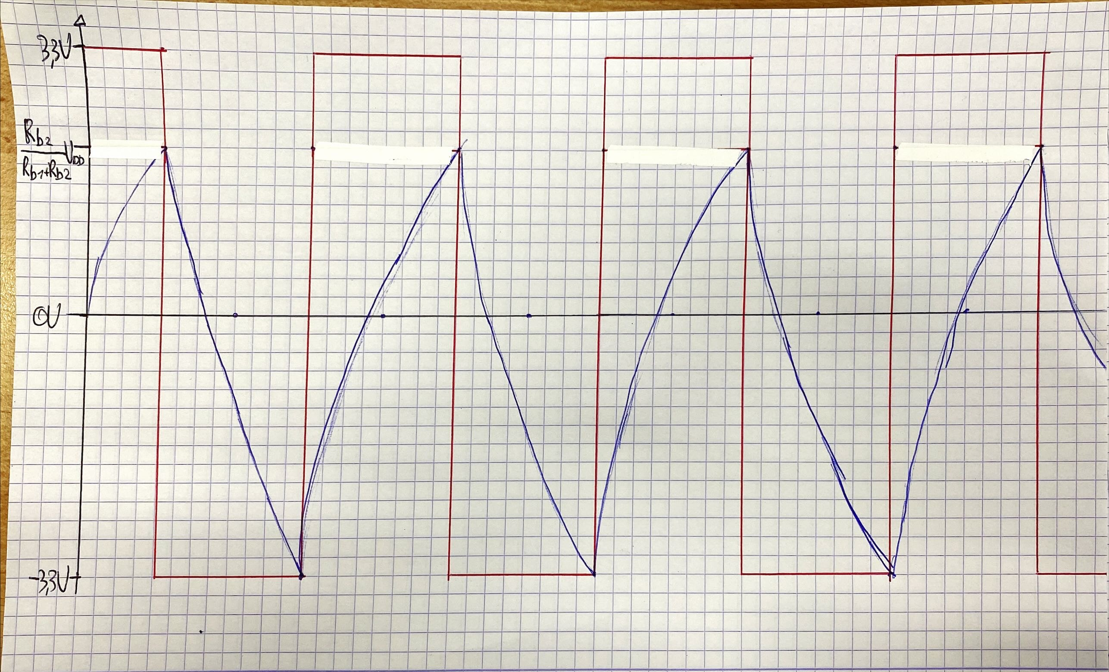   
Figure : oscillation in circuit with: capacitor voltage blue, and output voltage red

### Calculate the values of the components

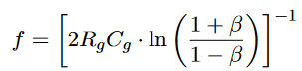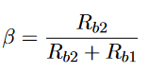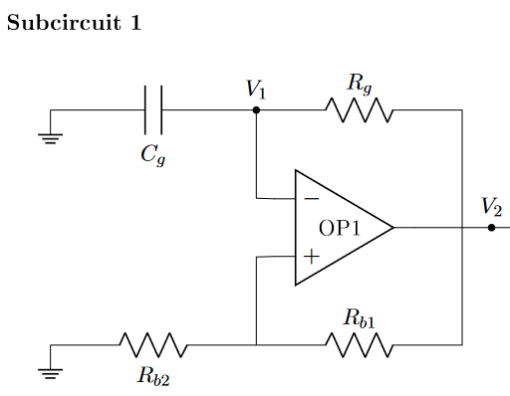

Assume β = 0.462 for easier calculation as in this case $\ln\left(\frac{1+β}{1-β}\right)=1$

Calculator => $solve\left(\frac{b}{b+a}=0.462, a, b\right)=>b=0.858736*a$

Rb1  = 10kΩ; Rb2 = 8.587kΩ.

f = (2* Rg * Cg)-1 => take R = 1kΩ => $solve({\left(2*1000*C\right)}^{-1}=10000,C)$ => C = 50nF

## Subcircuit 2

### What kind of mathematical function is achieved by this circuit

An integrator

### How does that mathematical function work in practice, i.e. how do the different elements (opamp, resistor, capacitor) enable to achieve it?

The main circuit is the RC network consisting of The resistor and the capacitor. When a voltage is applied the capacitor starts to charge with the current allowed through the resistor. This current through the resistor causes a voltage, which is integrated on the capacitor. The OPAMP causes a negative feedback to make the charging waveform identical to an integral.

### Design subcircuit 2 such that the output V3 has an appropriate shape, and the same amplitude and frequency as V2.

Assuming the capacitor charges in 5τ to Vin, from the RC constant. And each charge is half a period, τ needs to be 1/10 the period.

The period = 0.1ms, τ = 0.01ms = R*C

If we take R to be 1MΩ as it shouldn’t be high to not influence subcircuit 1, then:

$$solve\left(1000000*C=0.00001, C\right)=>C=1nF$$

# Simulation detail and simulations

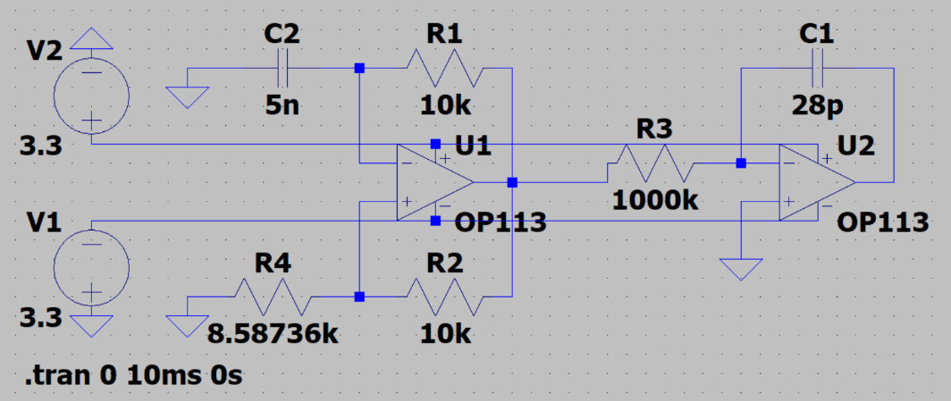

Figure : complete circuit with square wave oscillator and triangle oscillator

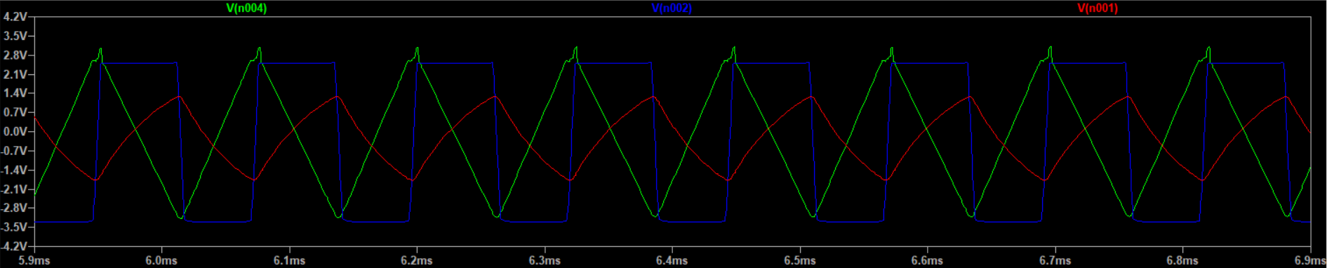

Figure : relevant signals to the circuit: triangle output in green, square-wave in blue, and Cg voltage in red

The square wave created as mentioned above, it is however not a perfect square wave as the edges are rounded, this can be due to OPAMP imperfections either in rise/fall times or in the comparative ability around the switching values. Not the square wave is between -3.3V and 2.5V, this will be discussed later. However the frequency seems to deviate as well, being a bit lower

The capacitor waveform is as expected as well, it shows the charge curve and the discharge curve in function of the square wave.

The triangle wave is rather well, it does show deviations on the top, but this due to the choice of components. The components were chosen by means of trial and error, as the ones calculated above did not result in a usable triangle wave. These values are chosen as optimal as possible while still staying stable. This is probably due to the frequency mis-matching

To fix the output voltage to the desired value an inverting amplifier can be used. Because the output voltage is 1V and the input voltage is 3.3V, the amplification needs to be about 1/3.03. The feedback resistor can be chosen as 1kΩ and the feedback resistor 3kΩ

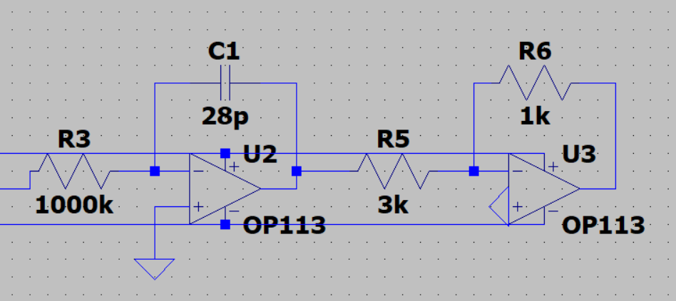

Figure : additional inverting amplifier added to the output

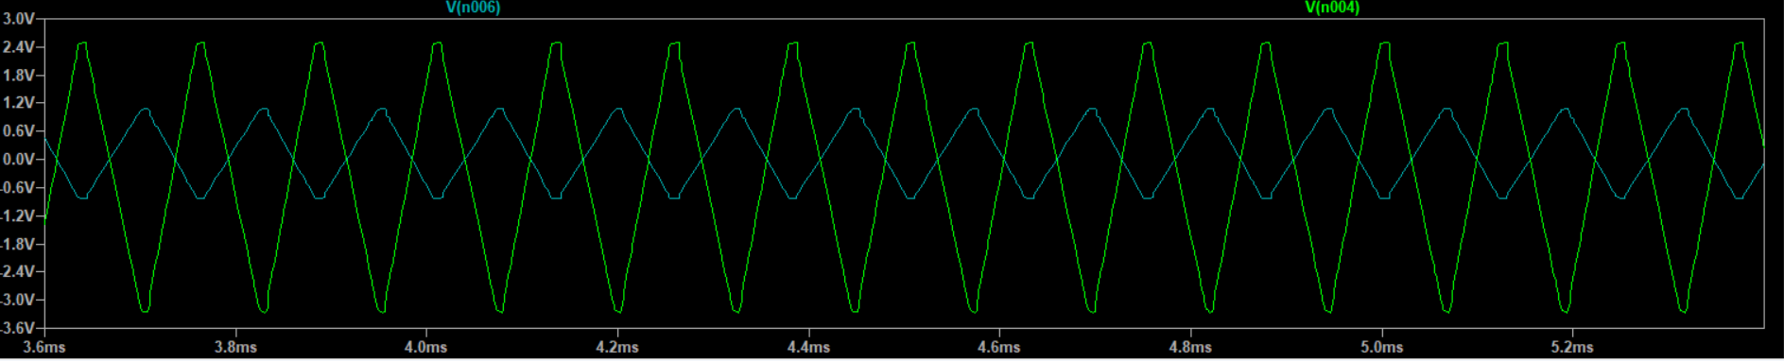

Figure : output waveforms showing the original triangle green and diminished output in cyan

# Conclusion

The circuit oscillated the correct waveforms, however a bunch of the calculations did not work, after close inspection the frequency of oscillation did not match the calculated one, as this one is around 8kHz instead of the desired 10kHz. This caused problems down the line at the triangle wave generator, where the values had to be chosen experimentally to get a good waveform. This might be an interesting topic to explore in a future lab.

Another observed topic is the use of large resistors between OPAMP subcircuits. When experimentally choosing the values for the triangle generator, it was discovered that a large input resistor greatly improved the performance of the signal, even at the same RC constant value. The recommended values here are 1MΩ, however this value comes close to the input impedances of the OPAMPS so a lower value of 10-100kΩ is probably the best.

Another observed phenomenon is that the square wave does not reach all the way to 3.3V but stays a constant value below it, a value of about 0.7V. This value is suspiciously close the bias voltage of a diode. And this is probably true as this OPAMP is not a rail-to-rail OPAMP and has probably a diode in the package. And this is furthermore another factor which could have influenced the deviation in frequency as the expected charging times are proportional to the voltage. The solution to this would be to use a rail-to-rail OPAMP.

Finally the inverting amplifier at the end of the chain brought down the voltage to around +-1V however, the measured values proved to be different. This is probably also due to the abovementioned deviations.

All by All the circuit did function in it’s rough specifications and this Labo was successful. However it does have a lot of room for another one with the objective to explore the deviations.